**How To Download (already completed but in case for future reference)**

1. The Gibbscluster 2.0 Package was downloaded from <http://www.cbs.dtu.dk/services/GibbsCluster/> upon request. Once the package was received by email, the compressed Gibbscluster package (gibbscluster-2.0e.tar.gz) was uncompressed inside the Downloads folder.
2. The gibbscluster-2.0 folder (approx. 500KB) was then moved into the Documents directory.
3. Inside the directory, open the “gibbscluster-2.0.readme” script with TextEdit. The following directions will be described inside this readme text file.
   1. Open the “gibbscluster” script with TextEdit. Locate the section starting with “GENERAL SETTINGS: CUSTOMIZE TO YOUR SITE”.
   2. Modify the statement: “setenv GIBBS …” with the full path to the ‘gibbscluster-2.0’ directory on your system. This was set to **setenv GIBBS /Users/legalllab/Documents/gibbscluster-2.0**
   3. Using terminal, move into the ‘gibbscluster-2.0/test’ directory by using the ‘ls’ (list directories) and ‘cd’ (change directory) commands to your discretion.
   4. Once inside the test folder, test the software by typing in these commands:
      1. **../gibbscluster -f test.pep -P gibbs > test.pep.myout**
      2. **../gibbscluster -f small.pep -P gibbs -C -I 1 -D 5 -gl-4 -S3 > small.pep.myout**
   5. The resulting files must be identical to ‘test.pep.out’ and ‘small.pep.out’ that are already in the ‘test’ directory.
   6. Each run creates a folder called giibs_{N} (or any other name specified with the -P option) where your results files are located. You may inspect the html report using:
      1. **open gibbs_{N}_report.html**

**Testing Your Peptide Sequences**

1. From your Excel file, copy and paste all sequences into a Word Document
2. Save the Word Document of the peptide sequences as a .txt file into the ‘sequences’ folder inside the ‘gibbscluster-2.0’ directory using the following format. This step is highly important because it will add new lines into the text file in order for the gibbscluster algorithm to work properly.

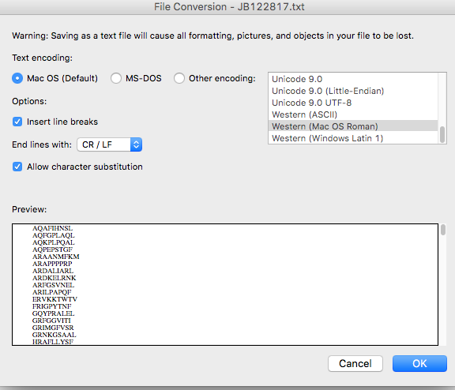

1. Using terminal, move into the ‘gibbscluster-2.0/sequences’ directory
2. Once inside the sequences directory, type this customized command into the terminal:
   1. **../gibbscluster -f AL121317.txt -P AL121317 > ../results/121317results.txt**
   2. **open AL121317_{N}/AL121317_{N}_report.html**

**Description of command:**

-f upload training set (Peptide || Peptide TAB Annotation)

-P name for this run (no spaces)

1. For a list of other available options, double-click on the ‘gibbscluster’ script and the options will open in terminal